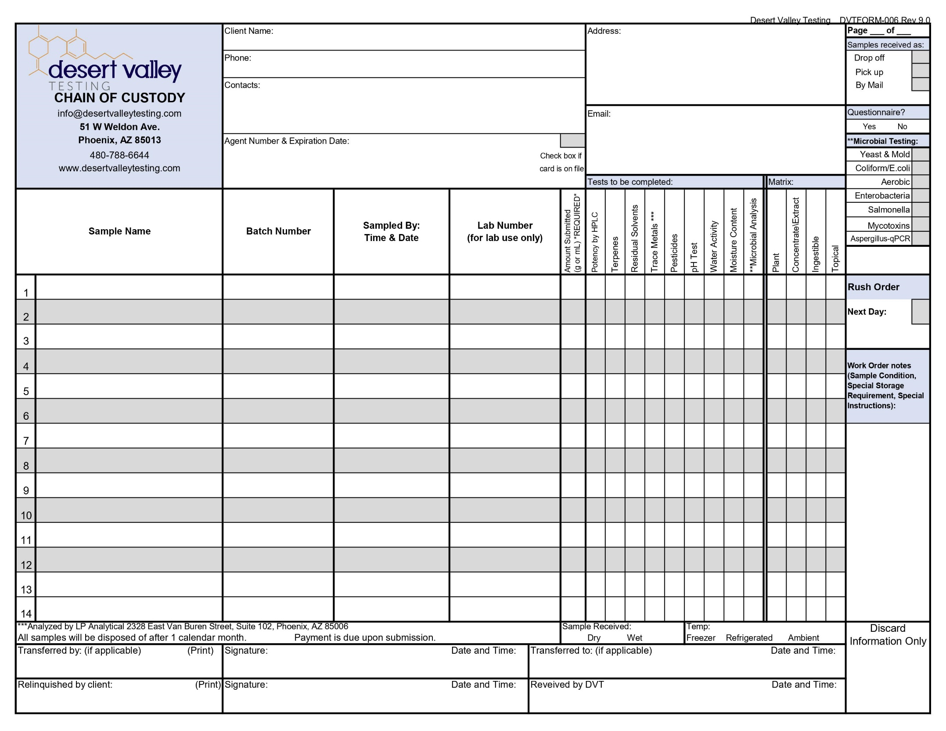
HOW TO COMPLETE YOUR CHAIN OF CUSTODY

All emails you want to receive results.
Check which Microbial test you want:
Any additional information you may have about your sample.

Sample Name J.Smith 5/12 1pm 1 X X
Sample Name II 123-45-67890 J.Smith 5/12 1:05pm 2 X X X

X
Amount of sample received.
LAB USE ONLY
If you’re testing cannabis, include your DA/patient information here.
All samples need to have the date, time, and who collected the sample.
Lab number is assigned by DVT for our reference.
Batch number, if applicable.
Main contacts we can reach for questions.
The contact information as you would like it to appear on your reports.
Your address.
Mark if a questionnaire is included.
X
Check if you want RUSH Services
Print, sign, date these boxes to relinquish your samples for DVT to test.
Each sample should have at least two boxes checked. The test wanted and the sample matrix (type).
How the sample was received.
The names of the samples as you would like them to appear on the report.
How many pages in the order.

